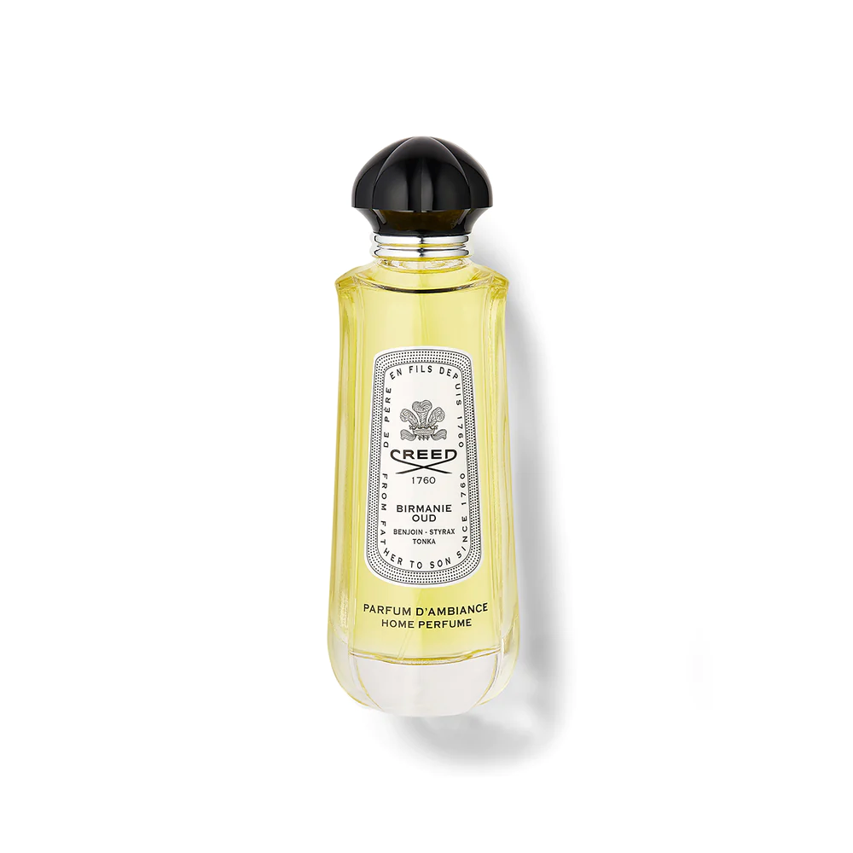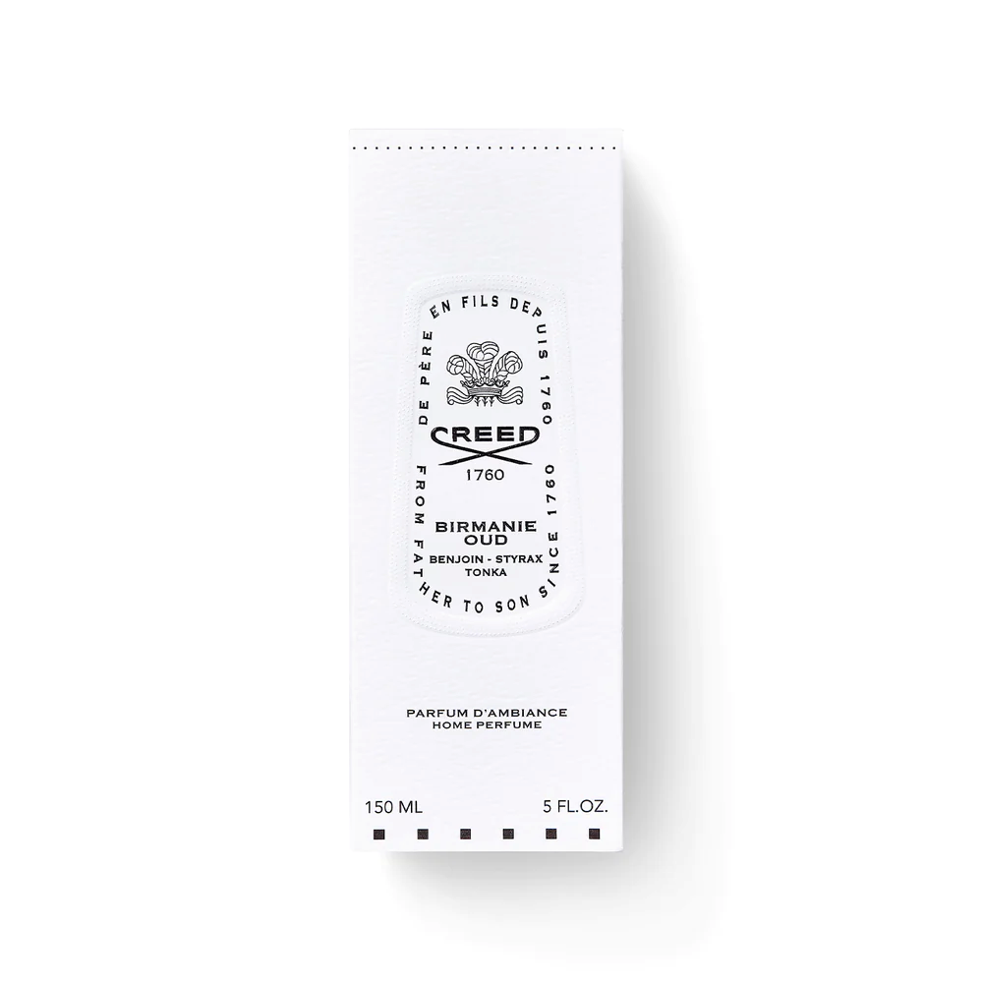

**BIRMANIE OUD HOME SPRAY**

$95.00

Tax Included.

Spray 100 mL

IN STOCK

### Product Details

Inspired by Olivier Creed’s expeditions in the Far East, this scent conjures the dark and resinous agarwood trees in Myanmar. Rich and luxurious, Birmanie Oud creates a sensual ambiance.

Featuring sumptuous and opulent ingredients, this long-lasting home perfume instantly creates a warm and optimistic space.